**Major Project Report**

**Submitted in partial fulfilment of the degree of**

**B.Tech**

**By**

**Nikita Kundu(11900120025)**

**Third year student of**



**Siliguri Institute of Technology**

**Under the supervision of**

Mr. Mainak Deb

**Sikharthy Infotech Pvt. Ltd.**



**Department of Computer Science And Engineering**

Date: 15/09/2022

I hereby forward the documentation prepared under my supervision by **Nikita Kundu** entitled **Siliguri Institute of Technology** be accepted as fulfilment of the requirement for the Degree of Bachelor of Technology (B.Tech) in **Computer Science & Engineering** from **Siliguri Institute of Technology** to **Maulana Abul Kalam Azad University of Technology** (**MAKAUT**) .

|  |  |
| --- | --- |
| ______________________________    **Mr.Mainak Deb**    **Project Guide**  **SikharthyInfotechPvt. Ltd.** | ____________________________________    **Nikita Kundu**  **Computer Science & Engineering**  **Siliguri Institute of Technology** |

**Human Face-Hand Detection With OpenCV Using Machine Learning**

By

**Nikita Kundu(11900120025)**

UNDER THE GUIDANCE OF

**Mr. Mainak Deb**

**Project Guide**

**Sikharthy Infotech Pvt. Ltd.**

THEIS SUBMITTED IN FULFILLMENT OFTHE REQUIREMENTS FOR THE DEGREE OF

**B.Tech**

IN

COMPUTER SCIENCE & ENGINEERING

**SILIGURI INSTITUTE OF TECHNOLOGY**

**AFFILIATED TO**

**Maulana Abul Kalam Azad University of Technology**

[**Address**](https://www.google.co.in/search?rlz=1C1GTPM_enIN734IN734&biw=1366&bih=613&q=future+institute+of+technology+address&stick=H4sIAAAAAAAAAOPgE-LVT9c3NEyrMC-JTzbO0JLNTrbSz8lPTizJzM-DM6wSU1KKUouLAYQ6jCEwAAAA&sa=X&ved=0ahUKEwi3htjS0_rbAhVLQY8KHTJnC-kQ6BMI1wEwEQ)**:**Hill Cart Road, Salbari, Sukna, West Bengal ,734009

[**Phone**](https://www.google.co.in/search?rlz=1C1GTPM_enIN734IN734&biw=1366&bih=613&q=future+institute+of+technology+phone&sa=X&ved=0ahUKEwi3htjS0_rbAhVLQY8KHTJnC-kQ6BMI6gEwEw)**:**0353-2778002 / 2778004, 0353-2778003 (Fax)

**Email:** [info@sittechno.org(Fax)](mailto:info@sittechno.org(Fax))

**Website:** <https://www.sittechno.org/>

**Certificate of Approval**

The foregoing project is hereby approved as a creditable study for the **B.Tech** in **Computer Science and Engineering** and presented in a manner of satisfactory to warrant its acceptance as a prerequisite to the degree for which it has been submitted. It is understood that by this approval the undersigned do not necessarily endorsed or approved any statement made, opinion express or conclusion therein but approve this project only for the purpose for which it is submitted.

Final Examination for

Evaluation of the Project ----------------------------------------

-----------------------------------------

------------------------------------------

Signatures of Examiners

------------------------------------------------------------------------------------------------

**ABSTRACT**

The purpose of the project entitled as “**Human Face-Hand Detection With OpenCV Using Machine Learning**” is to [**verify the identity**](https://www.electronicid.eu/en/blog/post/identity-verification/en)**of a person through its facial biometric pattern and data**.The technology collects a set of unique biometric data of each person associated with their face and facial expression to identify, verify and/or authenticate a person.

**ACKNOWLEDGEMENT**

It is a great pleasure for me to acknowledge the assistance and participation of a large number of individuals to this attempt. Our project report has been structured under the valued suggestion, support and guidance of **Mr.Mainak Deb**. Under his guidance we have accomplished the challenging task in a very short time.

Finally, we express our sincere thankfulness to our family members for inspiring me all throughout and always encouraging us.

**Nikita Kundu**

**Computer Science & Engineering**

**TABLE OF CONTENTS**

Chapter 1: Introduction

1: Introduction

Chapter 2: What We Used

2.1: Python

2.2: Deep Learning

2.3: Mechine Learning

2.4: IDE

Chapter 3: Functionality of the Project

3.1: Face Detection

3.2: Face Recognition

3.3: Hand Detection

4.4:Hand Gesture Recognition

Chapter 4:FEATURES

4.1: Detect Every Point of Face

4.2: Detect the Movement of Fingers

4.3: Counting numbers with Fingers

Chapter 5: System Analysis

5.1: Identification of the Face

5.2: Multiple no of Face Detection

5.3: Multiple no of Hand Detection

Chapter 6:Project Planning and Scheduling

Chapter 7: Functional Requirement of the System

7.1: Hardware Requirement

7.2: Software Requirement

Chapter 8: Conclusion

Chapter 9: References

1. **INTRODUCTION**

Face detection -- also called facial detection -- is an [artificial intelligence](https://www.techtarget.com/searchenterpriseai/definition/AI-Artificial-Intelligence) (AI) based computer technology used to find and identify human faces in digital images. Face and hand detection technology can be applied to various fields -- including security, [biometrics](https://www.techtarget.com/searchsecurity/definition/biometrics), law enforcement, entertainment and personal safety -- to provide surveillance and tracking of people in real time.

Face and hand detection has progressed from rudimentary [computer vision](https://www.techtarget.com/searchenterpriseai/definition/machine-vision-computer-vision) techniques to advances in machine learning ([ML](https://www.techtarget.com/searchenterpriseai/definition/machine-learning-ML)) to increasingly sophisticated artificial neural networks ([ANN](https://www.techtarget.com/searchenterpriseai/definition/neural-network)) and related technologies; the result has been continuous performance improvements. It now plays an important role as the first step in many key applications -- including face tracking, face analysis and [facial recognition](https://www.techtarget.com/searchenterpriseai/definition/facial-recognition). Face and hand detection has a significant effect on how sequential operations will perform in the application.

**2. PYTHON**

**2.1: PYTHON**

We used python 3.10.7 , In this project we learned about python data-types, string methos, list, touples, function, sorting, slicing and used some of this in our program.

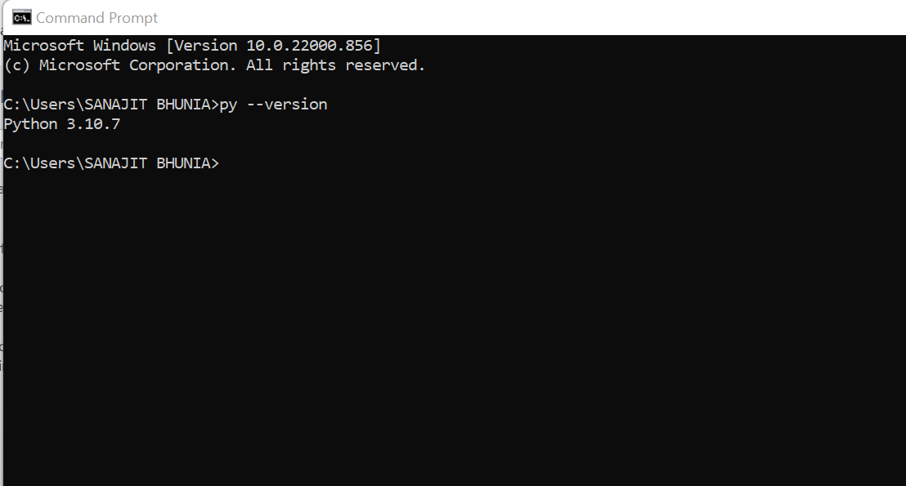

**2.2: Deep Learning:**

We use the concept of Deep Learning

**2.3: Mechine Learning**

We also used the concept of Machine Learning in this project.

**2.4: IDE**

We used Microsoft Visual Studio Code(VS Code) in our project as IDE.

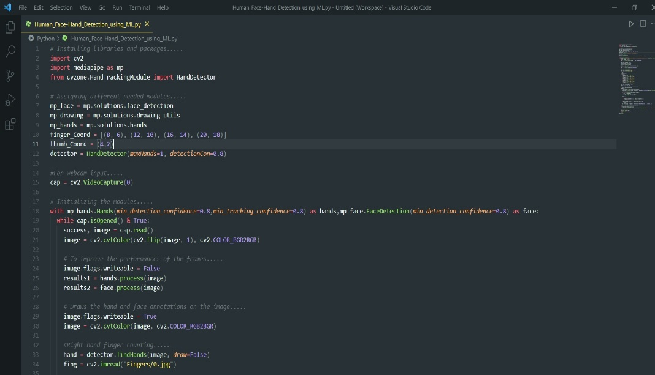

**3. FUNCTIONALITY OF THE PROJECT**

**3. 1:Face Detection:**

Face detection applications use algorithms and ML to find human faces within larger images, which often incorporate other non-face objects such as landscapes, buildings and other human body parts like feet or hands.

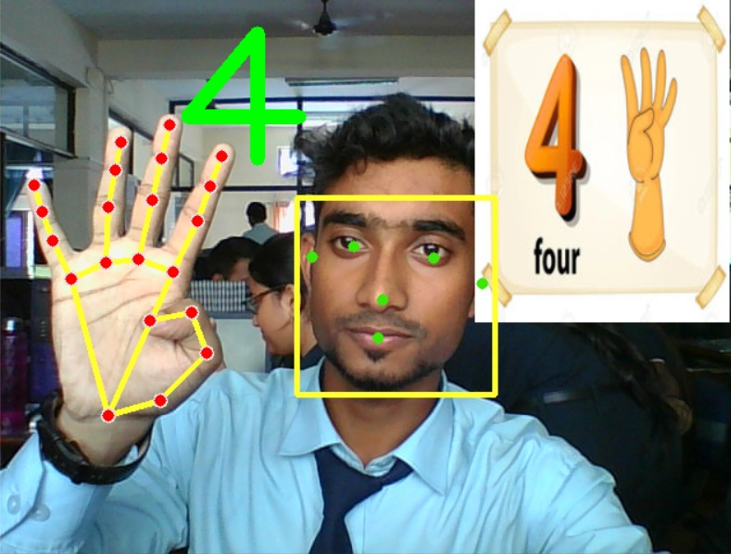

**3.2: Face Recognition:**

Face recognition is a method of identifying or verifying the identity of an individual using their face. Face recognition systems can be used to identify people in photos, video, or in real-time. Law enforcement may also use mobile devices to identify people during police stops. .

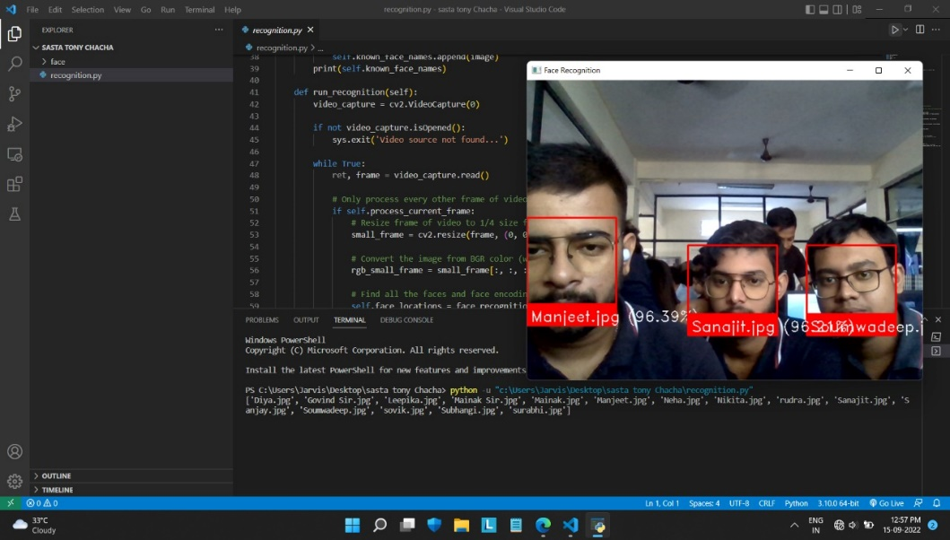

**3.3: Hand Detection:**

Hand tracking is the process in which a computer uses computer vision to detect a hand from an input image and keeps focus on the hand’s movement and orientation. Hand tracking allows us to develop numerous programs thatuse hand movement andorientation as their input.

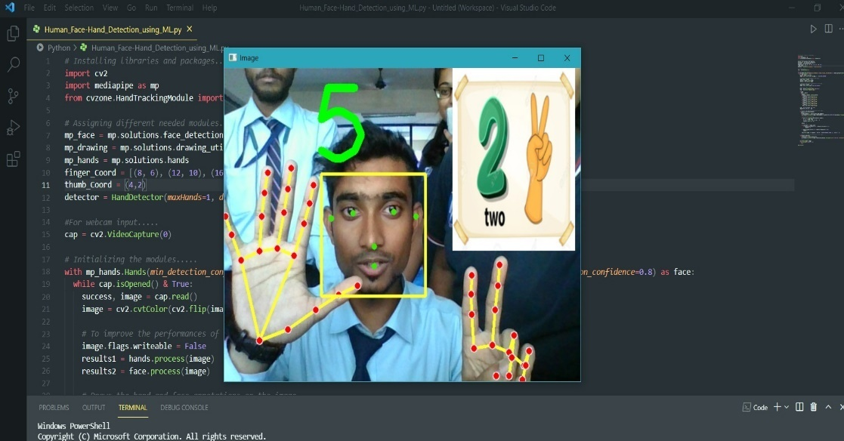

**3.4: Hand Gesture Recognition:**

A gesture recognition system starts with a camera pointed at a specific three-dimensional zone within the vehicle, capturing frame-by-frame images of hand positions and motions. This camera is typically mounted in the roof module or other vantage point that is unlikely to be obstructed. The system illuminates the area with infrared LEDs or lasers for a clear image even when there is not much natural light.



**4. FEATURES**

**4.1: Detect Every Point of Face:**

Detect Every Part Of Face Feature Allows The Examiner To Get More Accurate Reorganisation Of The Person Whose Photo Has Been Taken.

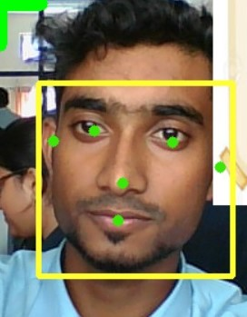

**4.2: Detect the Movement of Fingers:**

The finger tracking system is focused on user-data interaction, where the user interacts with virtual data, by handling through the fingers the volumetric of a 3D object that we want to represent. This system was born based on the human-computer interaction problem. The objective is to allow the communication between them and the use of gestures and hand movements to be more intuitive, Finger tracking systems have been created. These systems track in real time the position in 3D and 2D of the orientation of the fingers of each marker and use the intuitive hand movements and gestures to interact.

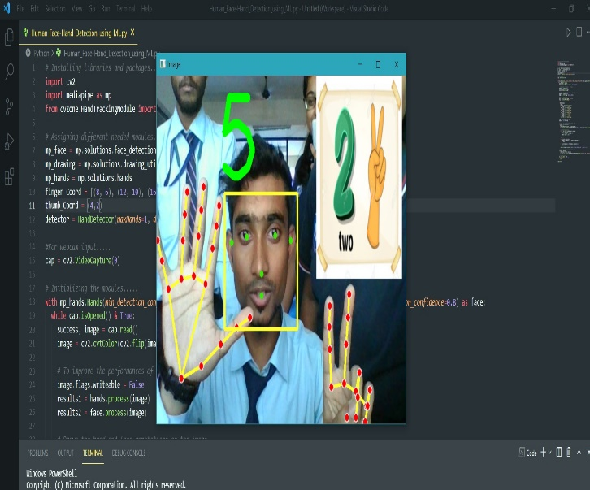

**4.3: Counting numbers with Fingers:**

Count the given numbers on your fingers and find the correct finger on which the number ends.

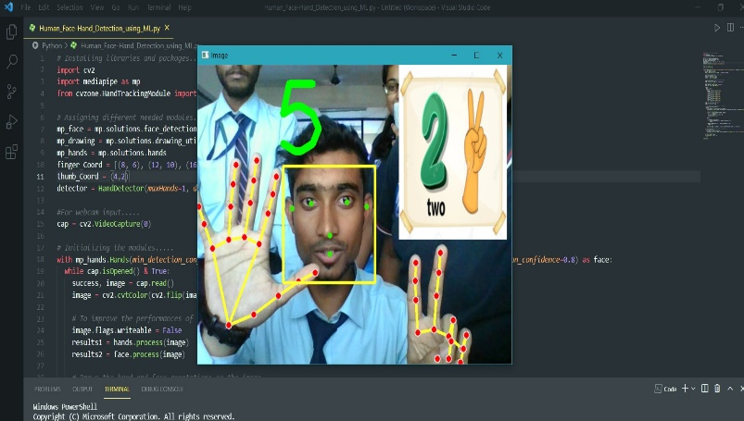

**5. SYSTEM ANALYSIS**

**5.1: Identification of the Faces:**

Face recognition systems can be used to identify people in photos, video, or in real-time.

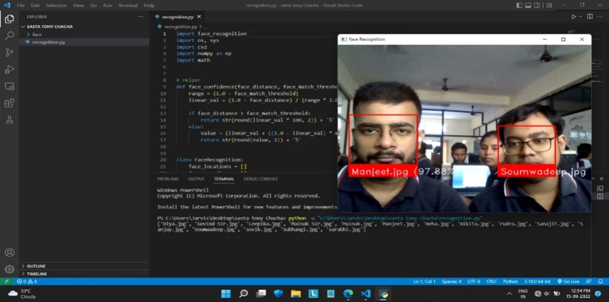

**5.2: Multiple no of Face Detection:**

It detect the multiple no of faces in a single frame.

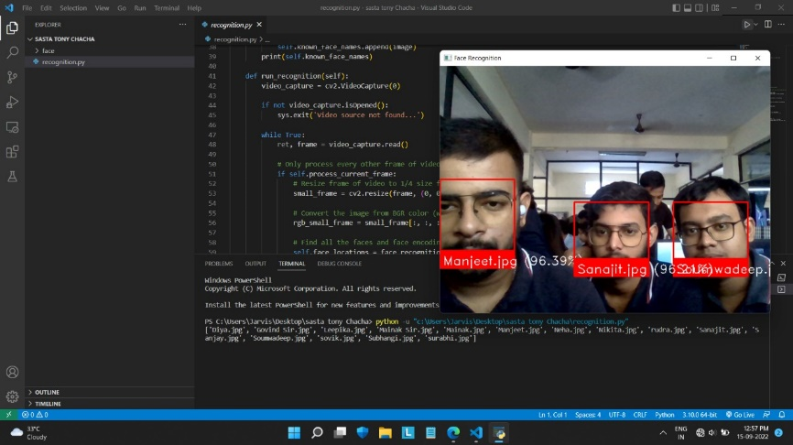

**5.3: Multiple no of Hand Detection:**

It detect the no of multiple hand.

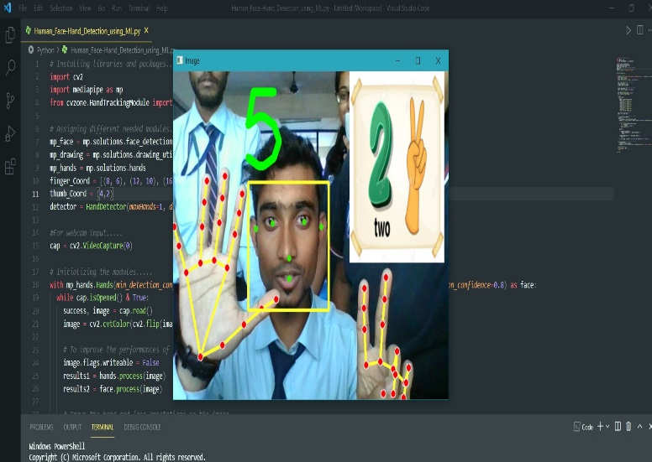

**6: PROJECT PLANNINGAND SCHEDULING:**

Scheduling is an important activity of any project management. Scheduling a software project involves first breaking down an entire problem into a logical set of tasks which would be assigned to developers. In order to Schedule the “**Human Face-Hand Detection With OpenCV Using Machine Learning**” wehave to do the following:

▪ Identify the tasks needed to complete the project.

▪ Determine the dependency among different tasks.

▪ Establish the most likely estimates for the duration of the identified tasks.

▪ Plan the starting and ending dates for various tasks.

▪ Determine the critical path i.e. the chain of tasks that determine the duration of the project.

**Step 1:** Face detection. The camera detects and locates the image of a face, either alone or in a crowd. ...

**Step 2:** Face analysis. Next, an image of the face is captured and analyzed. ...

**Step 3:** Converting the image to data. ...

**Step 4:** Finding a match.

**7. Functional Requirement of the System**

Being a web based solution the first and foremost thing that starts acquiring importance in this project is the way the complete package needs to be configured. Web-based solutions by virtue of their designs are mostly thin client solutions (unless they are heavy on DHTML). To run this kind of a solution properly it is necessary that the Server configurations are properly worked out. It is the server that will have to ultimately scale up as and when the numbers of users start increasing.

**7.1 HARDWARE REQUIREMENTS**

The minimum Hardware requirements for the application to run smoothly should have the following configuration:

|  |  |
| --- | --- |
| **Processor** | Intel Core i3 |
| **RAM** | 4GB or more |
| **HDD** | 3GB or more |

**7.2. SOFTWARE SPECIFICATIONS**

The minimum software requirements are as follows:

|  |  |
| --- | --- |
| **Operating System** | Windows 11 |
| **Language Used** | Python Language |
| **Web Browser** | Google Chrome, OPERA |
| **Working IDE** | Visual Studio Code |

**8. CONCLUSION**

Our Project **Human Face-Hand Detection With OpenCV Using Machine Learning ,** Is Created With The Help Of Python And OpenCV. We Have Tried Our Best To Implement:

* Face Detection
* Hand Movement Recognisation
* Face Detection With Their Name
* Counting Numbers With Fingers of Both Hands
* Synchronising Both Hands at the Same Time
* Multi Functioning of Both Hands

**9. REFERENCES**

1. https://www.w3schools.com/
2. <https://ieeexplore.ieee.org>
3. <https://www.javatpoint.com/>
4. <https://en.wikipedia.org>
5. https://www.kaspersky.com

**10. REPOSITORY LINK :**

<https://github.com/Nikitakundu2002/Human-Face-Detection>